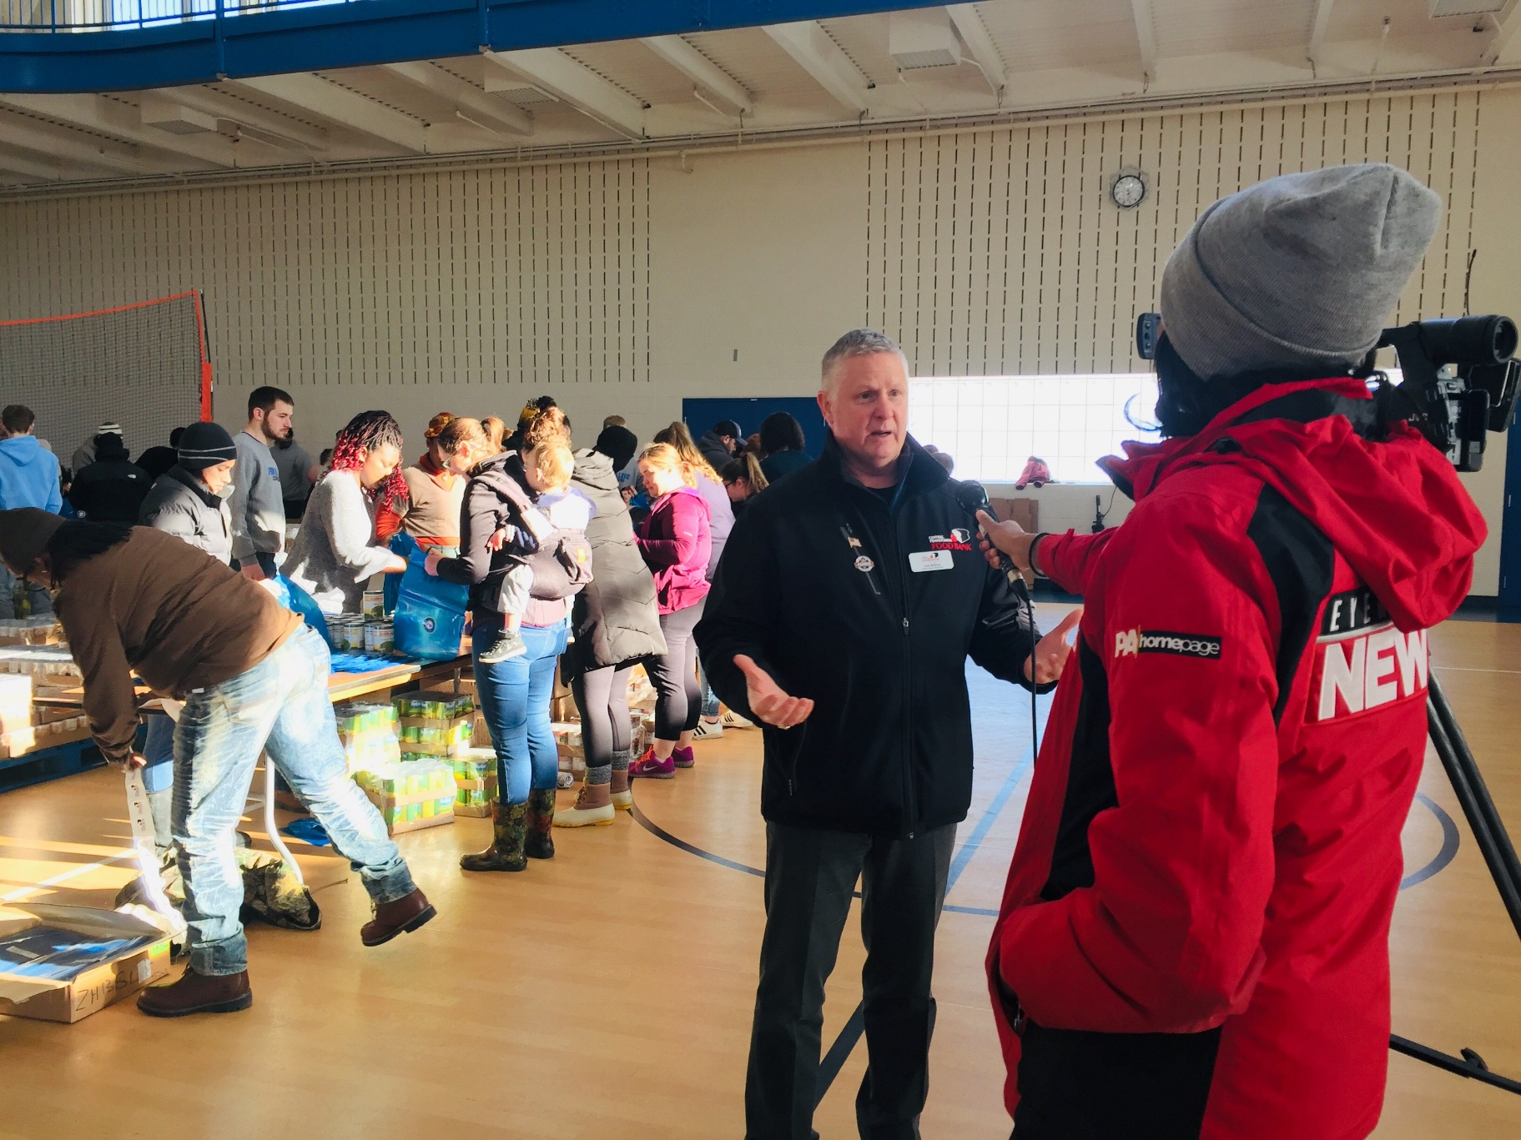

TOOLKIT

HOLIDAY MEDIA

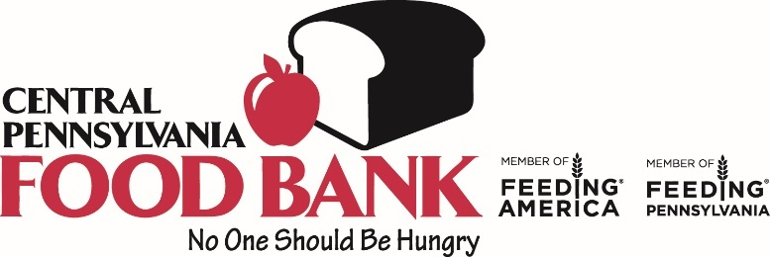

Welcome to the Central Pennsylvania Food Bank’s Holiday Media Toolkit! The following pages should serve as a resource guide to gain media attention for your holiday distributions. Media coverage increases awareness on the issues of hunger in your county, promotes the good work you are doing, as well as the partnership between your agency and the Central Pennsylvania Food Bank. As you look through the toolkit and have further questions or would like to request a Food Bank representative at your distribution, please reach out to our marketing team: info@centralpafoodbank.org.

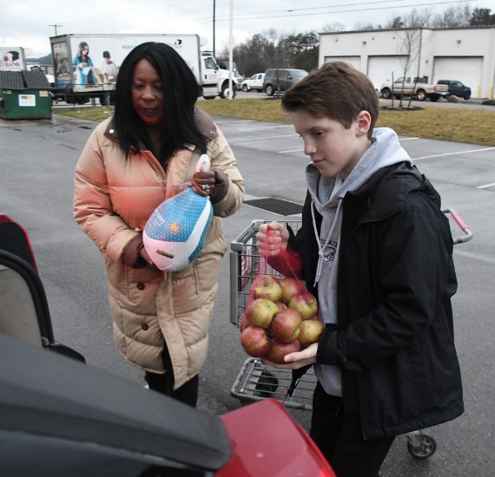
BETTER TOGETHER

COVID-19 shed a bright light on food insecurity and the importance of our mission. It reminded not only us, but the world due to the heightened media coverage around the pandemic, that anyone, at any time, in any circumstance, could need a little extra help keeping food on the table.

The pandemic also proved how powerful partnerships are in fighting hunger, improving lives, and strengthening communities. Together with you, our network of more than 1,300 partner agencies and programs throughout 27 counties, we serve over 152,000 individuals each month and provided:
- Nearly 50 million meals
- Nearly 14.5 million pounds of fresh produce
- Over 5.9 million servings of milk

The holiday season is an important time to re-engage with the community and to put the Food Bank and you, our partners, first on their minds when giving this holiday season to a charitable organization.
You have played an important part in providing support and hope to your community. Now it is time to let your work shine in the spotlight by contacting your local media affiliates about your upcoming holiday distributions.

Use the templates in this guide to connect with your media outlets in all forms (print, tv, radio) to make them aware of the upcoming distribution you are hosting. When media is on site, please be sure everyone working or volunteering with your organization is following CDC guidelines and is following safety protocols for your distribution.

We will continue to work towards a future where no one is hungry, and everyone has reliable access to nutritious food. Together we can leverage our mutual strengths to have a greater impact to help our neighbors. Not only have you been a constant to those you are serving, but you’ve provided nourishment and hope that fuels your clients heart and soul. Thank you for your continued commitment to the fight to end hunger.

What’s Included

- MEDIA ALERT
What is a Media Alert?
How to Format
Sending Out the Alert
Follow Up
Template
Example

- PRESS RELEASE
What is a Press Release?
How to Format
Sending Out the Release
Google Alert
Template
Example

- QUOTES FROM JOE

- MEDIA RELEASE FORMS
Separate attachment

What is a Media Alert?
Media alerts are one-page announcements of an upcoming event, intended for journalists, not the public. Their purpose is to convince reporters that this event is a genuine news story worthy of coverage. As an invitation to media it needs to be presented in a particular format.

How to Format the Media Alert
On the left, include the date of the alert and your contact information: that is, name, email address, and phone number. On the top of the page, type “Media Alert” in a large font, bolded, and all capital letters.
Format the invitation using the 5Ws of journalism:
- Who – individuals who will talk to media on-site at event
- What – event description
- When – date and time of event
- Where – location of event
- Why – why this event is a newsworthy story
At the bottom be sure to include your boilerplate description. In marketing, a boilerplate is a short paragraph summarizing a company and is used across all marketing materials. It is always the same and can be found at the bottom of press releases and reports, on the 'About Us' page of the website, and anywhere else where people may require a brief description of the organization. Be sure to add “partner agency of the Central Pennsylvania Food Bank” to your description.
Sending out the Alert
You should prepare the alert within 6 days of the event and submit it within 5 to 3 days prior to the event. This gives journalists the chance to pass along the information and attend themselves if they wish.
Next, prepare your list of who you will send it to. Aim for local journalists. Create a database of contacts you can connect with in future each time you want to send out a media alert via email. Make sure you have the contact information correct and spell their name right. Don’t be sloppy.
Send your alert in the body of your email, not as an attachment; Don't use logos or other image files – most reporters use smartphones (small screens!) and logos can hide or distract from the main information; Use links to provide more information.
Following up
Follow up the media alert with a telephone call to confirm that the reporters actually received it. Be polite and prepared to re-send the alert according to their instructions if they did not get it the first time.

MEDIA ALERT

MEDIA ALERT TEMPLATE

Date
For Immediate Release

Contact: NAME
Email:
Phone Number:

MEDIA ALERT
Story/Photo/Video Opportunity
(INSERT HEADLINE)

Who: Name persons in charge or individuals who will be authorized to talk to the media

What: Description of event

When: Date, Time. Include best time for photography and/or media interviews if applicable

Where: Place

Why: Description of the importance of the event

If this event is held in conjunction with the Central Pennsylvania Food Bank, include the following boilerplate:

About the Central Pennsylvania Food Bank:
The Central Pennsylvania Food Bank is a nonprofit organization whose mission is to reduce hunger in 27 counties across Pennsylvania. By working with more than 1,300 local agencies and partner programs, the Central Pennsylvania Food Bank serves over 152,000 neighbors in need every month. For more information on the Central Pennsylvania Food Bank and its mission to end hunger in Pennsylvania, visit centralpafoodbank.org or call 717-564-1700.

Include a boilerplate description of your organization

For Immediate Release

Contact: Carla Fisher
cfisher@centralpafoodbank.org
Phone Number: 570-321-8023

MEDIA ALERT EXAMPLE
Story/Photo/Video Opportunity
Subject: Holiday Distribution

Who: Joe Arthur, Executive Director of the Central Pennsylvania Food Bank
Gary Shipman, Social Services Director of the American Rescue Workers
Ron Frick, President of Lycoming County United Way

What: The Central Pennsylvania Food Bank in partnership with the American Rescue Workers will host a Holiday Healthy Box Distribution to over 500 low-income and in-need families in Lycoming County. The event is sponsored by Lycoming County United Way & Kellogg’s. Contents of the box include: frozen turkey, milk, eggs, potatoes, carrots, onions, apples, cereal, gravy, green beans, juice, and more.

When: Tuesday, December 17, 2019 –Best time for story/ photography/video is between 12:30 to 1:00 p.m. when the event starts. There will be two distributions on this day. 1:00 to 3:00 and 4:00 to 6:00 p.m.

*If there is inclement weather and only if the Central Pa Food Bank closes, the event will be moved to Friday, December 20 at 337 Bridge Street in Williamsport from 9am to 3pm. Please check the Food Bank’s website for any changes. www.centralpafoodbank.org

Where: Central Pennsylvania Food Bank, 3301 Wahoo Drive, Williamsport PA 17701

Why: The holidays can be a stressful time, especially for families who do not know where their next meal will come from. For children who rely on school resources for access to healthy food, holiday school closing can also be stressful. It is partnerships like this one, that we can make an impact and work toward our mission of fighting hunger, improving lives, and strengthening communities with a hands-on distribution at our Healthy Food Hub location with our partner agency American Rescue Workers. Better access to healthy foods means better health and a brighter future for those in need.

About the Central Pennsylvania Food Bank:
The Central Pennsylvania Food Bank is a nonprofit organization whose mission is to reduce hunger in 27 counties across Pennsylvania. By working with more than 1,300 local agencies and partner programs, the Central Pennsylvania Food Bank serves over 152,000 neighbors in need every month. For more information on the Central Pennsylvania Food Bank and its mission to end hunger in Pennsylvania, visit centralpafoodbank.org or call 717-564-1700.
PRESS RELEASE

What is a Press Release?
A press release is an official statement delivered to members of the news media for the purpose of providing information, an official statement, or making an announcement. The purpose of a press release is to get attention, make news, and generate publicity. It's cost effective marketing (free) and they can be used to create brand awareness.

Unlike a media alert where you are inviting media to an event, a press release details news about a business and can be released whenever as long as its newsworthy. A press release can also be used after an event has taken place, reporting on the highlights. It should read like a news story.

How to Format a Press Release
On the left, include the date of the alert and your contact information: that is, name, email address, and phone number.
- Headline: A title which grabs people’s attention and clearly explains what the release is about
- Location: Where you are and where the news is taking place
- Strong Lead: This is where you explain your newsworthy story/content in one sentence
- Body: It’s a very good idea to add in quotes throughout the body.
- Boilerplate: A few words describing your company to the audience. Be sure to add “partner agency of the Central Pennsylvania Food Bank.”

Sending out the Press Release
Since a press release details news about your business vs. inviting the media to an event, you can submit a press release anytime you want the story to run.

Just like a media alert, prepare your list of who you will send it to. Cast a wider net and submit to major news outlets as well as local journalists. Create a database of contacts you can connect with in future each time you want to send out a press release via email. Make sure you have the contact information correct and spell their name right. Don’t be sloppy.
Send your alert in the body of your email, not as an attachment; Don't use logos or other image files – most reporters use smartphones (small screens!) and logos can hide or distract from the main information; Use links to provide more information.
Google Alert
Sign up for Google Alerts to get emails when news for your organization is detected.

How to sign up for Google Alerts

- Go to Google Alerts.
- In the box at the top, enter a topic you want to follow.
- To change your settings, click Show options.
- Click Create Alert. You'll get emails whenever we find matching search results.

PRESS RELEASE TEMPLATE

For Immediate Release
Date:

Contact:
NAME
Title
Email
Phone

HEADLINE
Additional Subhead (if necessary)

(CITY, STATE) – Body of release

Quote from Food Bank: Please choose from the quotes on the following page

###

If event/news is held in conjuction with the Central Pennsylvania Food Bank, please include the following boilerplate
About Central Pennsylvania Food Bank
The Central Pennsylvania Food Bank is a nonprofit organization whose mission is to reduce hunger in 27 counties across Pennsylvania. By working with more than 1,300 local agencies and partner programs, the Central Pennsylvania Food Bank serves over 152,000 neighbors in need every month. For more information on the Central Pennsylvania Food Bank and its mission to end hunger in Pennsylvania, visit centralpafoodbank.org or call 717-564-1700.

Include an informational paragraph about your organization.

For Immediate Release
Date: September 10, 2020

Contact:
Carla Fisher
Communications and Marketing Coordinator
cfisher@centralpafoodbank.org
570-321-8023

CENTRAL PENNSYLVANIA FOOD BANK AND PARTNERS
MAKES SURE NO ONE GOES HUNGRY FOR THE HOLIDDAYS

(Williamsport, PA) – The Central Pennsylvania Food Bank in partnership with the American Rescue Workers held a Holiday Healthy Box Distribution to low-income and in-need families in Lycoming County. The event was sponsored by Lycoming County United Way & Kellogg’s. Contents of the box include frozen turkey, milk, eggs, potatoes, carrots, onions, apples, cereal, gravy, green beans, juice, and more.

The COVID-19 crisis revealed how vulnerable so many Pennsylvanians are to hunger. Many are just one missed paycheck away from financial hardship. While the signs of economic recovery are encouraging, food insecurity is still a stark reality for thousands of our neighbors as we head into the holiday season. Today, more than 337,000 central Pennsylvanians remain vulnerable to hunger.

“Hunger doesn’t take a holiday and neither do we,” said Joe Arthur, executive director of the Central Pennsylvania Food Bank. “Together with our network of local partners, donors, volunteers and friends we can be that glimmer of hope to hundreds of thousands of individuals, hardworking families and their children, seniors, and veterans to put a holiday meal on their table.”

The holiday distributions initially projected distribution to 500 families, but the lines of cars and people who showed up by foot soon far exceeded their initial number to twice that amount. Luckily the Food Bank and American Rescue Workers were prepared with extra holiday boxes on hand.

“The food we received is amazing,” said Jeanine Vital, who did not mind waiting in line. “Knowing that I can get help from the Central Pennsylvania Food Bank, that’s a plus. It’s not there to replace everything, but it’s there to help you along. And to be able to have a holiday meal, well that is really fantastic.”

The Central Pennsylvania Food Bank has been nourishing our community since 1982.They along with their more than 1,200 partners believe everyone deserves to have good, nutritious food—and enough of it to live healthy, successful lives.
To learn more about the Central Pennsylvania Food Bank and ways you can get involved to end hunger in our communities, please visit www.centralpafoodbank.org.

###

About Central Pennsylvania Food Bank
The Central Pennsylvania Food Bank is a nonprofit organization whose mission is to reduce hunger in 27 counties across Pennsylvania. By working with more than 1,300 local agencies and partner programs, the Central Pennsylvania Food Bank serves over 152,000 neighbors in need every month. For more information on the Central Pennsylvania Food Bank and its mission to end hunger in Pennsylvania, visit centralpafoodbank.org or
call 570-321-8023.

QUOTES FROM THE CENTRAL PENNSYLVANIA FOOD BANK
The following quotes may be tailored to your media alert or press release.

“The COVID-19 crisis revealed how vulnerable so many Pennsylvanians are to hunger. Many are just one missed paycheck away from financial hardship,” said Joe Arthur, executive director of the Central Pennsylvania Food Bank. “While the signs of economic recovery are encouraging, food insecurity is still a stark reality for more than 337,000 of our neighbors. (NAME OF AGENCY) is working on the front lines to make sure food is not an impossible choice for the people they serve every day.”

“The Central Pennsylvania Food Bank is proud to support (NAME OF AGENCY) working on the front lines to end hunger in their community,” said Joe Arthur, executive director of the Central Pennsylvania Food Bank. “This holiday season, we are providing ‘holiday boxes’ full of wonderful shelf-stable food that will accompany turkeys and other proteins, as well as fresh fruits and vegetables, sweet potatoes, eggs, milk, cheese, and more. And this year, we are also stocking food items that are preferred in diverse cultures. We hope this wholesome and healthy bounty will be shared at tables of loved ones and friends, with ample helpings of laughter and kindness.”

“The toll of 20 months of the pandemic has left many families and individuals in difficult financial circumstances, especially in rural communities and in communities of color,” said Joe Arthur, executive director of the Central Pennsylvania Food Bank. “The Central Pennsylvania Food Bank is working with its network of partners, including (NAME OF AGENCY) to ensure everyone in central Pennsylvania has access to enough food to sustain a healthy productive live, which is a basic human right. There is dignity in having food that tastes good, respects your culture and is good for you.”

